S m i t h s o n i a n A s t r o p h y s i c a l O b s e r v a t o r y & S t e w a r d O b s e r v a t o r y , T h e U n i v e r s i t y o f A r i z o n a

End of Trimester Summary


May - August 2008

Personnel

Dallan Porter left the MMTO May 1 for a position at the University of Arizona’s Flandrau Planetarium.

Dennis Jankovsky was hired as a General Maintenance Mechanic on May 19. Dennis was previously employed as a temporary maintenance worker at the Whipple Observatory.

Betty Stobie left the MMTO on May 21 to assume a position with National Optical Astronomy Observatories, across the street from Steward Observatory.

Ken Van Horn retired June 27 after 10 years of employment with MMTO.

Marilyn Guengerich accepted the position of Administrative Associate, replacing Barbara Russ, who is training to take over Howard Lester’s business manager duties when he retires October 3. Marilyn will start work October 6.

Talks and Conferences

Duane Gibson prepared and presented a paper, entitled "Optimizing real-time web-based user interfaces for observatories", for publication at the SPIE Astronomical Telescopes and Instrumentation 2008 Conference that was held June 23 - 28, 2008, in Marseilles, France. This paper addresses a major issue in using web-based technologies at the MMTO, and focuses on reducing the computer resources required to display web pages that contain data that update at 1 Hz. Results from approximately 20 different tests on different operating systems and web browsers were summarized in a poster that was presented at this conference. The paper has been published in the conference proceedings for the Advanced Software and Control for Astronomy II session.

Morag Hastie attended two conferences:

SPIE - Astronomical Instrumentation: oral presentation "Comprehensive Review of the Converted MMTs Instrument Suite" – June 23-28, 2008.

Cool Stars 15: poster presentation "A Novel Approach to Quantifying Chromospheric Activity in T Tauri Stars" - July 21-26, 2008.

Timothy Pickering also attended the SPIE conference in Marseilles and gave a talk on his paper titled “Modeling Temperature-induced Surface Distortions in the MMTO 6.5-meter Diameter Primary Mirror”. In the process of preparing the paper and talk he went through data from the WFS and thermal system logged during the month of May. He found that including the results of the finite element modeling presented in his paper could improve the performance of our open loop focus predictions by about a factor of two.

Primary Mirror Systems

Primary Mirror Support

Work continues on the LabVIEW program to evaluate RTV joints. Tom Gerl, after having learned the basics of LabVIEW, modified the program to receive data from three sources. Efforts continue to add filtering of the signals and produce a report file that contains the data.

Optics

The primary mirror was inspected by Randy Lutz on August 8, 2008. He inspected the previously treated fractures in the cassegrain hole wall of the primary mirror. His inspection showed no new damage, and all the treated fractures are stable. He suggested we continue the inspections every 2-3 years.

The primary mirror was washed in mid May. We had a very successful wash done with a dedicated crew who endured the strain of the task. Thank you all for lending a hand with this delicate and demanding step. It should maintain the coating for another year!

A series of weekly reflectance tests ensued after the wash. The photospectrometer was assigned to partners in early June; weekly tests will resume upon its return.

Below are the results compared to the December ‘07 wash. The numbers continue to look very good.

Thermal System

The first batch of T-series boards arrived and, after some necessary modifications, we began the laborious process of populating the boards and testing them with the lab calibration equipment. Once done, we will be able to guarantee that each board installed at the summit has undergone extensive testing against a real temperature reference (e.g. the reference platinum RTD in the lab). We anticipate finishing the absolute-measurement type boards first, then moving on to the differential (thermopile) boards.

Evaluation of the absolute thermal cards is progressing. After learning the basics of MATLAB, Tom Gerl wrote a program to evaluate the data gathered by the thermal tests, which greatly improved the efficiency of data evaluation. Some tests did not produce accurate numbers due to humidity in the cold plate and loss of network communication. These tests are being rerun. Thermal epoxy has been molded to 16 absolute boards and approximately eight thermopile boards. We currently await more epoxy to complete more boards.

Brian Comisso built the first enclosure for housing the thermocouple boards and the power supply. These will rack-mount and eventually supply all four available T-series system enclosures around the periphery of the primary mirror cell. We have in hand all the parts to complete the enclosures as needed.

Aluminizing

After the successful coating of the LOTIS mirror, the electronic equipment (data acquisition PC and welder interface rack, vacuum/coating system control rack, glow-discharge power supply) were moved to the campus labs for some needed facelifts. During the course of the LOTIS aluminization, it was noted that numerous issues with cabling, a fault within the AC output controls in the system control rack, and other “rough edges” needed attention.

We plan to rebuild the glow-discharge power supply rack to make the cabling more convenient, add digital panel meters for the output, and clean up the tungsten light-bulb based input current regulator circuitry. The data acquisition PC required many Windows updates, and cleanup of its (nearly full) hard disk. Dallan Porter was able to accomplish most of this work before his departure from MMTO. Finally, the system control rack needs to have its I/O cable interface moved to the rear of the enclosure to avoid the need for reaching inside to connect the various sensor cables. This also gives us the opportunity to clearly label all the data acquisition points, and to ensure that the MySQL database inputs and the physical data acquisition points properly relate. We had difficulty connecting signal cables for troubleshooting purposes in the past, which tends to scramble the arrangement of data in the acquisition system.

Currently, the PC has been brought up to date and tested, the data acquisition rack has been completely rewired, a new set of rear panels have been constructed and populated (except for one specialty connector), and the glow discharge power supply has been largely rebuilt. We expect to finish all the work before years end, and will store the gear in anticipation of 2009 summer aluminization of the MMT primary mirror.

Work is almost complete on the modifications to the aluminization control cabinets. The variable load box is complete and awaits retest. The monitoring box awaits six cables and the completion of one panel.

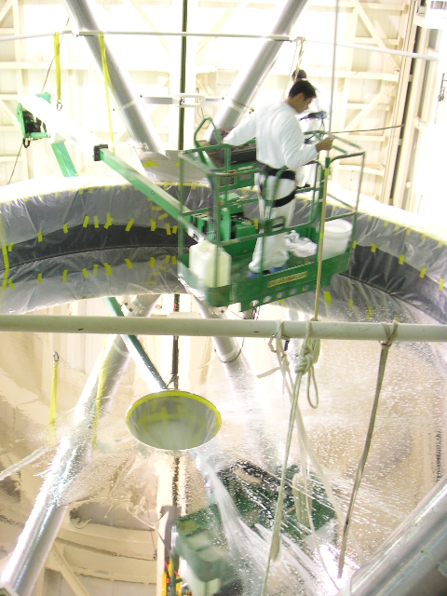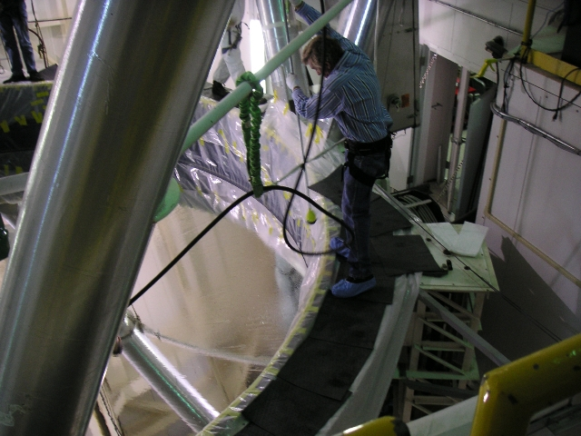

R. Ortiz maneuvers over the primary mirror The mirror edge is “blow-dried” with filtered
while “dabbing” the surface with a soapsuds- high pressure air.
filled large cotton swab.

Upon completion of the LOTIS aluminizing project, MMTO acquired the major components of a large pumping station (the new MMT turbo pump V701). In preparation for its use at MMTO, we have purchased several fittings and parts, but still need a vacuum gauge controller from MKS Instruments and a couple of vacuum sensors. We expect this pump to be available soon.

The controller for our main Turbo pump (V6000) was serviced at the factory in Italy, returned to the MMT, and tested. All expenses were covered by LOTIS. The unit is now stored at the common building and ready for next year’s coating.
Secondary Mirror Systems

f/5 Secondary Support

The f/5 secondary axial support system was adjusted and tuned. One third of the axial actuators of the f/5 secondary were not sharing the load of the glass while the support system was powered off. The lengths of these actuators were adjusted so that the load is now shared by all.

f/5 Secondary Baffles

The pneumatic actuator fittings on the mid-level baffle were replaced. The new 90 degree fittings remove a pinch point in the air line that feeds one end of the pneumatic actuators that extend the lower ring of the baffle.

f/15 Secondary

A thin shell removal system was designed and fabricated for the f/15 secondary. The purpose of the system is to remove the thin shell of the f/15 secondary for cleaning and maintenance. The system uses a hand-cranked, adjustable-height cart and a precision digital scale, along with the previously existing shell holder, to safely lift the shell off its clips. The shell support tool is mounted on the scale, which is placed on the cart. The force applied by the tool to the shell is monitored by the scale while the cart height is adjusted to remove and install the shell. The cart then lowers the shell so it can be rolled out and serviced. This system is much safer and controllable than the previous technique where two people manually held the shell tool up to the mirror.

A new PI panel is being designed to aid in the cabling of the f/15 secondary. The new panel, for the back of the rack, will clearly label all connections required for installation and operation of the f/15 secondary mirror.

New UPS battery packs are ready for installation to extend the battery life for the f/15 system on a loss of power.
Telescope Tracking and Pointing

Servos

The MMT servos were deployed with an early version of the disturbance-decoupled controller in late 2007. Several issues cropped up over the first few months of operation; the most aggravating was an unforeseen “windup” issue due to the unconstrained available output from the disturbance decoupling path in the controller. It would grow to large values, which were compensated by the main position loop’s PID compensator, and the two would combine in a way that could lead to large unwanted DAC output values. This, in part, is what drove the elevation axis to collide with the building at the end of July. The implemented fix was to apply limits to both the disturbance decoupling path and the position loop PID output, with the position loop always having more available authority than the disturbance decoupling signal. This prevents any windup from growing in an unbounded, uncontrolled way.

Skip Schaller has become more actively involved in the ongoing work to improve the mount servo software, especially developing plans to avoid system software related problems.

We also have implemented many changes to the nightly logging system to make analysis of the tracking on a nightly basis more convenient. More work is yet to be done on improving the disturbance rejection of the elevation-axis servo, but good progress has been made, and the current performance routinely exceeds 0.1” RMS tracking performance.

Computers and Software

Primary Mirror Thermal Software

Duane Gibson developed and implemented automated control software for the M1 ventilation system. This software forms the new "vent_servo" mmtservice. The new software became operational in June 2008, and represents a major advance in control of the M1 ventilation system. The current version of the control software uses both the Carrier and pit Neslab to regulate the temperature of conditioned air entering the lower plenum of the M1 cell. The Carrier and pit Neslab work in a complementary manner in which the Carrier supplies the majority of the cooling, but the pit Neslab provides: 1) quick response to temperature changes, 2) finer temperature control, and 3) additional cooling capability. Tuning of the control software continues.

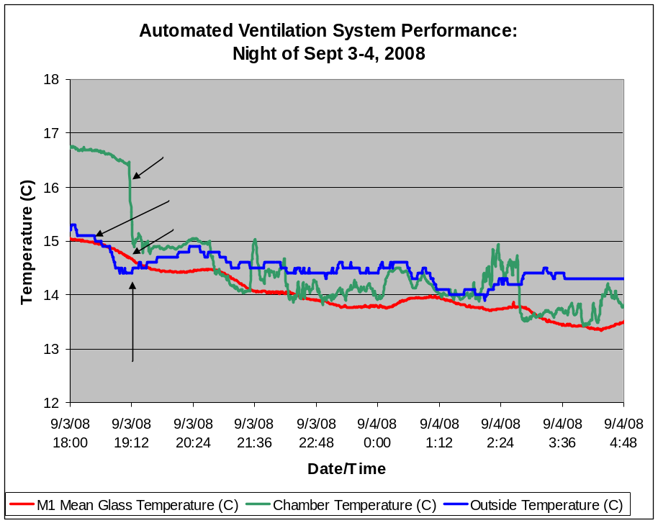

Figure 1.
Figure 1 shows the behavior of the control system on a recent night of typical telescope operations. The major objective of the control algorithm is to keep the M1 glass temperature (shown in red) slightly below (i.e., a few tenths of a degree C) the colder of the chamber temperature (in green) and the outside temperature (in blue). The chamber temperature 1 is from the Yankee thermohygrometer (model MET-2010), and the outside temperature is from the west Vaisala model WXT510 (vaisala4). This control strategy minimizes the local seeing related to air-glass temperature contrasts in front of the primary mirror. Using the colder of these two air temperatures is particularly beneficial when the chamber is opened and closed repeatedly during the night because of variable weather conditions or other operational conditions. Details of this control system will be presented in an upcoming MMTO tech memo.

Duane Gibson collaborated with Morag Hastie on archived primary mirror E-series data. This work focuses on the impact of instruments with high heat output at the Cassegrain focus for the MMT.
Miniservers

Work continues on updating code for the 2-3 dozen miniservers. These miniservers communicate with a wide range of hardware devices, provide network access to data from these units for other software clients, and log associated data. This work includes: 1) combining separate client and server processes into one process, 2) transferring miniserver configuration data from code into a centralized MySQL database, and 3) updating associated GUIs and web pages to use the centralized miniserver configuration data. Migration of the five TempTrax digital thermometer miniservers has been completed. Work continues on the miniservers that support the four Vaisala remote weather stations.

SAO Guider

During this reporting period, Skip Schaller added an offset function to the saoguider software. The operator can now simply click on a star and the telescope will move so as to place the star in a target box. He also configured saoguider to work with the maestro guide camera. One parameter, the maestro camera rotation angle, has still not been determined due to lack of on-sky time.

Thermocouple Calibration Software
Many components of the new T series temperature measurement hardware have unique calibration parameters that need to be determined. Software was written to assist in the calibration process. A server runs continually and acquires data from the T-series controller via the network (when the controller is up and running). A web based GUI displays current values in real time, but also can instruct the server to place readings in a database, along with setup information describing the particular configuration of the calibration equipment. The database thus serves as a record of system performance, as well as allowing calibration parameters to be determined.

Miscellaneous Software

Work also continues on improving performance of web-based Ajax applications. The Ajax portions of hexoffsets, hexpositioner, and hexpods GUI's have been updated to use the DOMNode Javascript class presented at the SPIE conference. Use of the xajax library was removed from the code.

Duane Gibson collaborated with Shawn Callahan on archived wind data for the MMT. This work addresses design issues for a new facilities support building at the summit of Mt Hopkins.

Duane Gibson continued support for modifying and updating web pages. Plots related to elevation and azimuth drive servo data were converted from CGI scripts to mod_python scripts. Associated wind data plots were modified to use the more extensive MySQL database for vaisala3 and vaisala4 data rather than the related RRDTool databases. Numerous other changes were made to web pages.

New software projects were started in support of the electronics and adaptive optics efforts at the MMTO. A web-based GUI and associated MySQL database were created to be used for calibration of new thermocouple boards. Several tens of thousands of calibration measurements have been taken by the MMTO electronics staff. An additional web-based GUI and MySQL database was also created for measuring actuator temperatures for the f/15 adaptive optics secondary.
Instruments

f/15 Instrumentation

Natural Guide Star (NGS)

The f/15 shell was removed from the reference body and cleaned in July. This was done by Richard Sosa (CAAO), Thomas Stalcup, Ricardo Ortiz, Creighton Chute, and Morag Hastie (MMTO). This was the first time using the new shell handling equipment, courtesy of Creighton Chute.

Skip Schaller is becoming more familiar with the AO software, and is currently working on a new implementation of the science server.

Laser Guide Star (LGS):

During the May run, the NGS arm of the LGS topbox was tested as a low-bandwidth wavefront sensor. This is to address the expected static aberration in the closed loop LGS images. The NGS arm is known to have minimal aberrations, so any aberrations measured by the NGS wavefront sensor are removed by adding offsets to the LGS loop. At the end of the run, improvements were seen using this technique, but problems with the loop prevented running at a high enough gain to get significant amounts of correction. It was determined later that one contributing factor preventing the use of high gains was in the tip/tilt correction loop. The tip/tilt commands were unknowingly routed through a gateway on campus when changing from the internal to the external MMT network. On the last night of the run it seemed that either the gateway machine or some other point in the route had unusually large delays, causing instability in the tip/tilt loop.

f/9 Instrumentation

Blue and Red Channel Spectrographs

During summer shutdown, the Blue and Red Channel cameras were sent to ITL for yearly maintenance. The dewars were baked, pumped, and tested warm. The AzCam software was not updated since the MMT uses an ICE interface. The PCI card drivers, which are compatible with both ICE and the newest versions of AzCam, were updated on the mmtccd computer.

The SOGuider camera was also sent to ITL during summer shutdown. A replacement mmtguider system, with a Magellan controller, was built and delivered. The new system was tested with both the mmtguider and the spare mmt2guider dewars. Because the two dewars have different CCD detector types, the gain is vastly different. The system was optimized for mmtguider. If and when mmt2guider is used, a hardware change is needed to adjust for the different gains. ITL is looking into simple solutions for this issue. The new PC is mounted on the Magellan (MAG) controller and is called mmtag.

The new guider system draws 48 Watts of power, not including the TEC power. The controller draws about 18 W, and the PC about 30 W. The internal TEC power supply has been removed from the Magellan controllers since it was not being used and added noise. The PC power supply is now in the Magellan controller case (blue box).

With the upgrade of the SOGuider, the rack mount PC that had been called mmtag has been converted to mmtccd. This allowed the main science computer (mmtccd) to be moved from the yoke room to the third floor east racks. The Windows software on the mmtccd computer was updated.

The ARC controller gen3 PCI card that was in the mmtag computer has been added to the mmtccd computer so that MAESTRO can use mmtccd for science observing in the future. For the December MAESTRO run, the science fibers will be plugged into the new PCI card in mmtccd and not the MAESTRO PC as has been done in the past. The maestroccd computer in the MAESTRO electronics box will be used for guiding only. The AzCam software will be copied from the maestroccd computer to the mmtccd computer and tested in December prior to the MAESTRO run.

ITL provided the MMT with a spare gen1 CCD controller, power supply, and cable to be used as an on-site spare for Blue Channel.

f/5 Instrumentation

Hecto

The Hectochelle and Hectospec runs in May and June were productive. A z=5 qso was found among many good object spectra. The June Megacam run was hampered by computer communication issues. An adjustable frequency laser system was set up and successfully tested in July. The illumination level with this system is more uniform across the spectral range, enabling this system to provide better calibration of the line positions in Hectochelle spectra.

The long run in July was a near washout for Hecto — only a few hours of observing between all the rain showers. The positioner therefore did not get exercised as much as it might have. The robot 1 Theta axis continued to give some following error problems on the few instances that the positioner was powered on. The home position on the robot 2 Theta axis became bistable, jumping back and forth by about 20 microns on different home moves, which suggests that the settings in the EP box had drifted. The robot 2 Phi axis plus limit also had an anomalous reading on at least one of the home moves, and is suspected of spuriously triggering system halts during a few fiber configurations. These issues were addressed in August by machining a new part to provide better alignment between the robot 1 Theta parts, replacing the servo amp for that axis, replacing the robot 2 Phi limit sensor and cable, and re-calibrating the EP box circuits.

The front surface of the wide field corrector — the surface which is exposed to the sky — was thoroughly cleaned during the August service trip with the help of Dian Nutter from Gooch and Housego (formerly Cleveland Crystals Inc.), the company that applied the SolGel coating. It looked great. Most of the dust and the brown spots of unknown origin, which appeared earlier this year, were removed by the process. Other surfaces and regions of the corrector assembly were also cleaned with vacuum cleaners, blown air, tweezers, etc.

Multiple network issues arose during the trimester, and a new network configuration for the SAO instrument network was implemented. A duplicate connection, which was left in place initially, caused a few additional problems but has been fixed. Lewis, Clark, and Wavefront are now the only SAO computers directly on the MMT network. The other SAO systems, like Hardware for the positioner, Snappy for the guiders, and the various camera computers, are routed to a second ethernet interface card on Clark and Lewis. This should isolate these systems from improperly assigned IP addresses on the general web, which caused problems earlier in the year.

MMIRS

During May, the MMIRS team successfully completed a controlled cool-down and warm-up of the camera dewar of the instrument for the first time. This included testing of redesigned heaters, the grism assembly and drive mechanism, the temperature sensors, and the gate value assembly. However, the optical lenses, grisms, filters, and detector were not installed during the test. Most mechanisms performed satisfactorily. The next cool-down occurred June and included all the optics, filters, grisms, detector, and test slit masks.
General Facility

Chamber shutter seals
The chamber shutter seals were sealed by addition of a backing strip. A missing section of flashing above the chamber hatch was discovered and repaired. The chamber has been tested now in driving rains and is rain and light tight.

Freon air conditioning system
The drive room air fan-coil unit was removed and found to be damaged beyond repair. SAYCO heating and air conditioning was awarded a contract to replace and install fan-coil units in the drive room and second floor west lab.

Instrument repair facility
The instrument repair facility 65% review was completed in mid June. Many staff contributed comments and questions to guide the architects. Computational fluid dynamic models generated in ANSYS show the instrument repair facility does not degrade the seeing of the telescope.

Spectrograph fire suppression
The Smithsonian project office contracted with Durant Architecture to investigate a fire suppression system for the third floor west spectrograph room and a mountain-wide alarm interconnection. Joe Zajac (SAO) tested a sample of fire retardant (FE-25) and saw no detrimental effects on the spectrograph coatings.

An end-of-shutdown "all-hands" cleaning day was held at the summit on Tuesday, August 26. The day was a success but it only scratched the surface. We plan to have similar cleaning days at least twice a year.

Summer Shutdown

2008 MMT Summer Shutdown: Completed Task List

- Serviced the hecto fiber positioner (SAO with MMTO support)
- Cleaned the front surface of the f/5 wide-field corrector (SAO and Gooch & Housego with MMTO support)
- Re-grouted damaged areas of the building track, one major location and two minor locations
- Realigned and leveled the building track
- Cleaned the building track
- Serviced the facility power distribution and quiet power
  - performed a general ground violation inspection
  - replaced the undersized ground node
  - repaired a number of electrical violations
  - added a new knife switch in the pit
  - verified grounding for the computer UPSes
  - documented power distribution
- Replaced > 20 Hepa sub-micron filters in the blower
- Repaired a crack in the heat exchanger aluminum ducting (FLWO welding support)
- Serviced the rollers on the front shutters; inspected, measured and adjusted the followers
- Serviced the seals around the doors of the pit heat exchanger
- Organized the cable drapes
  - over the east and west yokes
  - to the 2nd floor west SAO racks
  - to the 3rd floor east AO racks
  - along the OSS
- Inspected and greased the azimuth pintle bearing
- Greased the building wheels
- Cleaned and greased the bull gear in the yoke room
- Serviced the gear boxes in the yoke room
- Began work on the loading dock lift
  - cleaned the hole
  - identified electrical configuration
  - performed repair work on the lift
- Upgraded the f/9 guider to use the new Carnegie/Magellan controller (ITL)
- Inspected the Cass hole mirror cracks (Randy from the Mirror Lab)
- Lubed drive screws in the f/9 topbox
- CO2 cleaned the optics in the f/9 topbox and f/5 WFS (shorter wand)
- Serviced the f/5 secondary support system; adjusted 1/3 of the axial actuators and inspected the tangent rod pucks
- Removed and cleaned the f/15 shell (new handling jig)
- Moved the east wind sensor (Vaisala 3) to the flagpole
- Moved the west wind sensor (Vaisala 4) to the west side of the pole
- Serviced and calibrated the Dustracks unit
- Identified and repaired a number of leaks in the chamber
- Serviced the blower; changed the oil and greased the zerks
- Replaced and repaired a leaky cylinder on the instrument lift
- Began documenting the glycol system
- Cleaned and organize the tool boxes
- Cleaned the yoke room
- Gathered for an “all-staff” general cleaning of the facility

Two sections of the building track were regrouted, and one section was shimmed. We also checked for levelness and verified that only three sections needed repairs at this time. The cow catchers were cleaned and aligned to the track. After regrouting, the track was cleaned and dry lube applied. The pit was also cleaned and organized.

Several images from the regrout of the track in the pit.

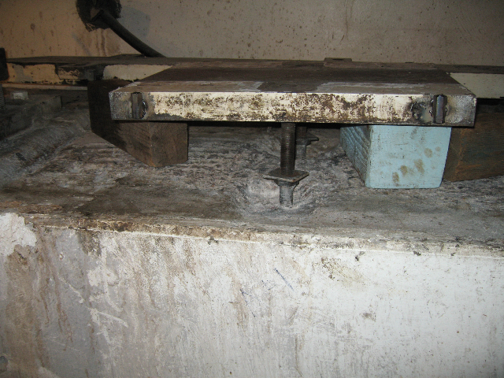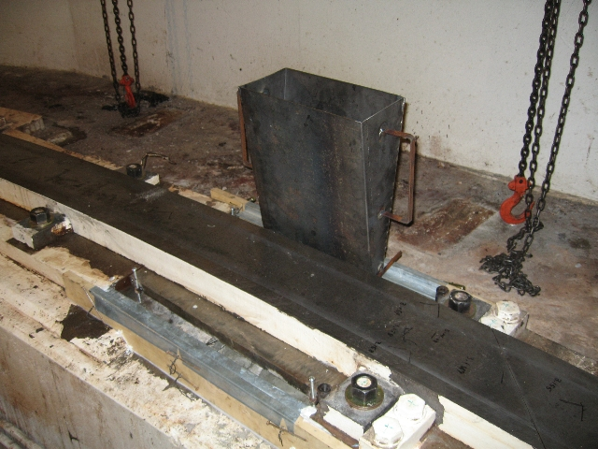

Old grout has been removed and the The track section alignment is verified,
track reset. forms are readied for extruding cementous
grout under the track and sole plates.

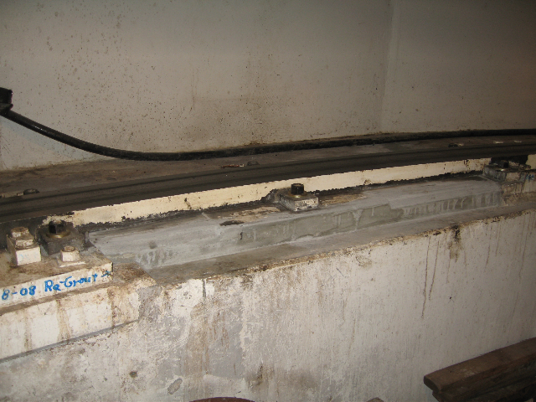

Grout is successfully placed; curing cycle is
underway.

We serviced the front shutters, which had been noisy when opening and closing. The followers were adjusted and the build-up of dirt in the track was removed. After cleaning, we used dry lube to help with the correction needed by the wheels to compensate for the doors not being square.

The heat exchanger door seals in the pit were replaced and have tested leak-tight.

The building wheels in the pit were inspected, the keepers checked, and the bearings repacked with grease. The swing arms were greased.

The four gearboxes in the yoke room were drained and refilled with oil. The alignment was checked against the bull gear.

The f/9 top box and f/5 wavefront sensor (WFS) were cleaned with Co₂, using our new, shorter spray wand.

The zero instrument lift in the chamber had a leaky hydraulic cylinder. The spare unit was installed, and the leaking unit was repaired and is ready as a spare.

The yoke room was mopped with degreaser, cleaned, and organized.

The roof seals were redone after the roof contractor’s seals started leaking. The source of some leaks still remains to be found.

The Goodway lathe in the shop was repaired.

The Gardner Denver compressor was repaired, and both Gardner Denver compressors and the Mattei compressor were serviced.

The summit shop work bench was hardwired, as requested by the SI safety committee.

Unnecessary wiring and Neslab equipment was removed from the AC system rack in the pit.

The energy chains on the east and west side of the telescope were redressed.

The drive room rack cabling was cleaned up and unnecessary components removed.

The main MMT computer’s UPS was repaired after a power outage identified faulty battery packs.

The building skirts were cool-coated, and leaks in the paneling were repaired. The lifts at the common building and summit loading dock were reinforced.

Ken Van Horn continued mountain systems tutorials (blower motor, rotator, and 26V rack) for the electronic staff.

A significant effort was mounted by Creighton Chang, Brian Comisso, John Di Miceli, and Cory Knop to rework all the cables in both the east and west elevation drapes. Many cables had been improperly installed by non-MMTO personnel and required quite a lot of work to correct. Other cables were found that had worked and rubbed their way across the cable trays until they were strained, and some PI-panel cables that had broken entirely. This was all corrected and the cable drapes are now in excellent shape. Cable runs in the ceiling of the 2nd floor above the SAO equipment racks were also cleaned up.

Telescope Quiet Power

Approximately two weeks was spent during summer shutdown to address the quiet power system; there had been reports of poor AC power-system quality from PI instrument scientists. The Quiet Power system within the MMT Building is deliberately designed with an isolated ground system to segregate loads that create electrical noise from loads that require low noise, and is fairly complex; many changes over the years and the course of the 6.5m Upgrade were poorly documented and understood.

We began with a survey by B. Comisso to identify problems in the AC wiring. We discovered unwanted ground-node currents flowing to the quiet-power copper node in the base of the telescope pier, and other wiring issues. To begin, a new 2/0 isolated ground cable was connected from the power transfer switch to the main node in the pit, replacing a cable that was undersized for the safety ground connection. We also installed new power cable (part number CO-04HOE (4/0) SJ2000 MIL-C-3432E) from the pit quiet power disconnect to the 1st floor quiet power circuit breaker panel. The new cable eliminated the old undersized cable as well as a junction box splice in the pit. The pit quiet power 25kVA transformer was also rewired. Several ground loops in the transformer to load panel wiring were removed as well as superfluous wires. The transformer, a delta primary to wye secondary, has its output neutral connected directly to the main node in the pier, as required by code. We note that 25kVA is just half the rated output of the MGE UPS, and plan to upgrade this transformer as funds become available.

Tom Welch, FLWO electrician, installed a fused disconnect on the output side of the MGE UPS on the wall of the UPS/compressor room. This switch will allow us to totally isolate the MGE output, and serves to protect the primary side of the pit quiet power transformer, and de-energize the quiet-power feed when needed.

To ensure isolated ground was in fact isolated several days were spent tracing all the ground wiring in the building. The main isolated ground was disconnected in the transfer switch and each individual line was verified to be isolated from earth ground. A plethora of violations (e.g. connections to house ground, or interchanges of house and isolated ground) were found throughout the building. On the first floor, the new fire alarm station, SAO control monitors, SAO racks in yoke room, AO racks in yoke room, and new outlets in yoke room all had violations of the isolated ground. The second floor had a few violations in an outlet box in the west instrument storage room. The third and fourth floors had a few minor violations. All of the problems were corrected except the problems in the yoke room. A new isolated ground wire will need to be run from the main isolated ground and the outlets changed over to orange isolated ground outlets. Another issue is the SAO/AO rack, which violates the isolated ground. We have disconnected it from power and the violation is still there. The power flow will need to be checked to determine the problem.

While doing this work, we ran across other issues: the discovery of a ground loop on the MGE output to the safety ground from the pad-mount 112KVA transformer, a neutral-to-ground loop that was a consequence of the way the 112KVA transformer was wired to the transfer switch, and a primary-secondary neutral interconnection on the Elgar isolation transformer for panel Q3 on the 3rd floor. We need to upgrade the transfer switch to a 4-pole unit to open the ground/neutral loop that exists when the 112KVA transformer is connected to the transfer switch neutral wire. Currently, the transformer neutral conductor is disconnected, and the transfer switch is placarded to disallow selection of the transformer. A vendor and unit have been identified as a candidate for this upgrade, and we await final engineering review and funding availability from SAO for this work.

The last area of quiet power to be checked was the Filtron quiet power panels on each floor (Q2 through Q4). All the panels had corroded wiring and failing insulation on the cables into the main circuit breakers. The wire was cut back to a barrel splice and replaced with 2/0 welding cable. The new splice is a crimp barrel covered in high voltage/current heat shrink. Circuit breaker lugs in all the Q panels that had stranded-conductor load wiring over the old-style screw terminal lugs also received new set-screw fittings to correctly attach the wires to them.

Additionally, the main cover panels were modified to eliminate the plastic slide buttons that were not user friendly. The front panels have been powder-coated and labeled to improve circuit breaker identification. The 3rd floor panel is slightly different than the others; it has a split power section with an Elgar isolation transformer feeding the panel (this is a legacy from the 4.5m MMT – the 3rd floor used to be the main computer room). The transformer was found to have the neutral input and the neutral outputs bonded together. The bond was removed and both neutrals are now independent from each other.

While a lot has been accomplished, there is still a lot to do with quiet power. SAO has made available a new Fluke Power Quality Meter that we plan to use soon to survey all the AC load systems within MMTO’s infrastructure to identify and document the delivered power quality on the summit. This survey will quantify and document the delivered quiet power quality and may lead to further improvements in the system. As of today, one astronomer has stated that our quiet power is now as quiet as or quieter than our noisy power. That's an improvement over a previous concern that our noisy power was quieter than quiet power.

Weather and Environmental Monitoring

The WXT-510 (Vaisala 3) was removed from behind the support building and sent in for repairs. Vaisala evaluated the unit and, due to extensive repair cost, the unit was replaced with a newer WXT-520. At the same time, a new mounting location on the east flagpole was prepared. Brackets and a mount were fabricated, and the new unit was installed and is mounted facing southeast, preventing the pole from affecting the measurement of the easterly winds.

The Vaisala unit on the west flagpole worked well all summer and provided the following statistics for nighttime environmental conditions on the summit:

There were some periods of good seeing in May and June, but it was more often fair to mediocre or worse. The median seeing (corrected to zenith) for May was 0.76” which is close to the historical median. June and July were somewhat worse. The August data is only for one night, August 1.

Visitors

September 25-26: As part of a program on exoplanets, NOVA scienceNOW filmed the installation of several new MEarth telescopes at the former satellite tracking station (APT site) on the Ridge. They also filmed at the MMT.

October 3: A group of Smithsonian Associate members visited the MMT, accompanied by Dan Brocious (FLWO), and dined at the Ridge afterward.

October 9: A French film crew shot footage at the MMT, and other US observatories, for a feature movie. The film, “Around the World, Around the Sky 2009”, is a homage to astronomers for the International Year of Astronomy 2009.

Publications

MMTO Internal Technical Memoranda

None

MMTO Technical Memoranda

None

MMTO Technical Reports

None

Scientific Publications

08-20 Absolute Properties of the Main-Sequence Eclipsing Binary Star GX Geminorum: Constraints on Convective Core Overshooting
C. H. Sandberg Lacy, G. Torres, A. Claret
AJ, 135, 1757

08-21 Spectroscopic Determination of the Luminosity Function in the Galaxy Clusters A2199 and Virgo
K. Rines, M. J. Geller
AJ, 135, 1837

08-22 A Photometric Search for Transients in Galaxy Clusters
D. J. Sand et al.
AJ, 135, 1917

08-23 SPITZER/IRAC Search for Companions to Nearby, Young M Dwarfs
P. R. Allen, I. N. Reid
AJ, 135, 2024

08-24 A Large-Scale Optical-Near-Infrared Survey for Brown Dwarfs and Very Low Mass Stars in the Orion OB1 Association
J. Downes, et al.
AJ, 136, 51

08-25 FUSE Determination of Abundances in Long-Period Pulsating V1093 HER (PG 1716+426) Stars
J.-P. Blanchette et al.
ApJ, 678, 1329

08-26 From Shock Breakout to Peak and Beyond: Extensive Panchromatic Observations of the Aspherical Type IB Supernova 2008D Associated with Swift X-Ray Transient 080109
M. Modjaz et al.
Submitted to ApJ

08-27 Photometric Redshifts and Signal-to-Noise Ratios
V.E. Margoniner, D.M. Wittman
ApJ, 679, 31

08-28 The Luminosity Function of X-Ray-Selected Active Galactic Nuclei: Evolution of Supermassive Black Holes at High Redshift
J.D. Silverman, et al.
ApJ, 679, 118

08-29 The Kinematic Properties of the Extended Disks of Spiral Galaxies: A Sample of Edge-On Galaxies
D. Christlein, D. Zaritsky
ApJ, 680, 1053

08-30 Spitzer Observations of the Massive Star-Forming Complex S254-S258: Structure and Evolution
L. Chavarria, et al.
ApJ, 682, 445

08-31 Luminosity Function Constraints on the Evolution of Massive Red Galaxies since z ~ 0.9
R. Cool, et al.
ApJ, 682, 919

08-32 SDSS J142625.71+575218.3: The First Pulsating White Dwarf with a Large Detectable Magnetic Field
P. Dufour, et al.
ApJ, 683, L167

08-33 Evidence of N₂-ice on the Surface of the Icy Dwarf Planet 136472 (2005 FY09)
S. Tegler, et al.
Icarus, 195, 844

08-34 Comprehensive Review of the Converted MMT’s Instrument Suite (Proceedings Paper)
M. Hastie, B. McLeod
Proc. SPIE, 7014, 70140B

08-35 Smithsonian Widefield Infrared Camera (Proceedings Paper)
W. Brown, et al.
Proc. SPIE, 7014, 70142P

08-36 MMT-Pol: An Adaptive Optics Optimized 1-5µm Polarimeter (Proceedings Paper)
C. Packham, T.J. Jones
Proc. SPIE, 7014, 70145F

08-37 Commissioning the MMT Ground-Layer and Laser Tomography Adaptive Optics Systems (Proceedings Paper)
N. Mark Milton, et al.
Proc. SPIE, 7015, 701522

08-38 A Test Stand for the MMT Observatory Adaptive Secondary (Proceedings Paper)
T. Stalcup, et al.
Proc. SPIE, 7015, 701565

08-39 Modeling Temperature-Induced Surface Distortions in the MMTO 6.5 Meter Primary Mirror (Proceedings Paper)
T.E. Pickering
Proc. SPIE, 7017, 701718

08-40 Image Motion Correction Using Accelerometers at the MMT Observatory (Proceedings Paper)
T. Stalcup, K. Powell
Proc. SPIE, 7018, 70181H

08-41 The MMT f/5 Optical Baffles (Proceedings Paper)
S. Callahan, et al.
Proc. SPIE, 7018, 701843

08-42 PCR: A PC-based Wave Front Reconstructor for MMT-AO (Proceedings Paper)
V. Vaitheeswaran, et al.
Proc. SPIE, 7019, 70190E

08-43 A Nonlinear Disturbance-Decoupled Elevation Axis Controller for the Multiple Mirror Telescope (Proceedings Paper)
D. Clark, T. Trebisky, K. Powell
Proc. SPIE, 7019, 70192J

08-44 Optimizing Real-Time Web-Based User Interfaces for Observatories (Proceedings Paper),
J.D. Gibson, T.E. Pickering, D. Porter, S. Schaller
Proc. SPIE, 7019, 70192Q

Non MMT Scientific Publications by MMT Staff

Spectroscopic Observations of Mercury’s Surface Reflectance during MESSENGER’s First Mercury Flyby
W. McClintock, et al., F. Vilas
Science, 321, 62

Observing Reports

Copies of these publications are available from the MMTO office. We remind MMT observers to submit observers’ reports, as well as preprints of publications based on MMT research, to the MMTO office. Such publications should have the standard MMTO credit line: “Observations reported here were obtained at the MMT Observatory, a facility operated jointly by the University of Arizona and the Smithsonian Institution.”

Submit publication preprints to bruss@mmto.org or to the following address:

MMT Observatory
P.O. Box 210065
University of Arizona
Tucson, AZ 85721-0065

MMTO in the Media

No activity to report.

MMTO Home Page

The MMTO maintains a web site (http://www.mmto.org) that includes a diverse set of information about the MMT and its use. Documents that are linked to include:

- What’s New at MMTO.
- General information about the MMT and Mt. Hopkins.
- Telescope schedule.
- User documentation, including instrument manuals, detector specifications, and observer’s almanac.
- Scientific and technical publications
- A photo gallery of the Conversion Project as well as specifications related to the Conversion.
- Information for visiting astronomers, including maps to the site.
- The MMTO staff directory.

Observing Database

The MMTO maintains a database containing relevant information pertaining to the operation of the telescope, facility instruments, and the weather. Details are given in the June 1985 monthly summary. The data attached to the back of this report are taken from that database.

NOTE: Beginning January 2005, the formula for accounting lost time on the telescope has been changed. Previously, time lost to weather was deducted from the total observing time before calculating time lost to instrument, telescope, and facility from the remaining balance. From now on, the time lost to each source is computed as a fraction of the total scheduled time.

And beginning June 2005, a new category, environment, was added to account for time lost to natural, uncontrollable, non-weather events such as flying insects melting in laser beams and forest fires.

Use of MMT Scientific Observing Time

